--5. List the people who made the booking for room number 209 on 26th Nov 2016.

Test 1 :

CREATE or ALTER VIEW vRoom209

AS

SELECT TOP concat (first_name, ' ', last_name) as 'guest name' , room_no, booking_date

FROM booking

INNER JOIN guest ON booking.guest_id = guest.id

WHERE room_no ='209' and booking_date = '20161126' ;

GO

SELECT * FROM [dbo].[vRoom209]

Table 'guest'. Scan count 0, logical reads 2

Table 'booking'. Scan count 1, logical reads 5

SQL Server Execution Times:

CPU time = 0 ms, elapsed time = 92 ms

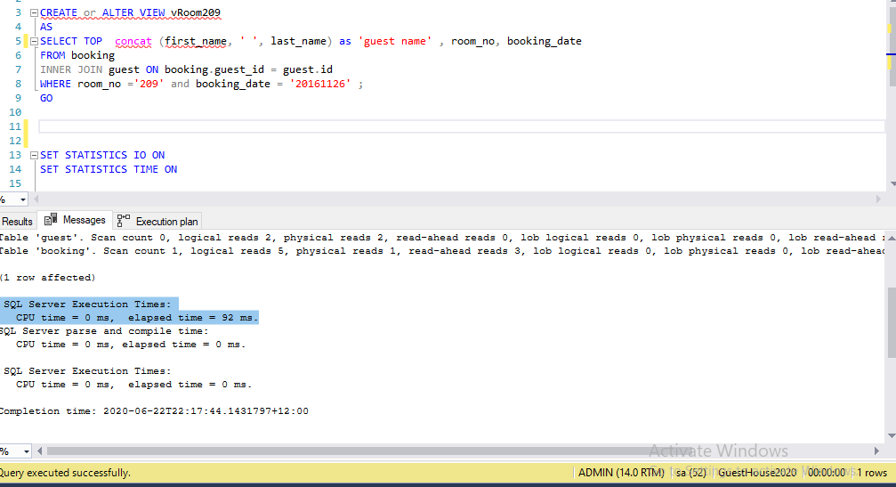

TEST 2

CREATE or ALTER VIEW vRoom209

AS

SELECT TOP 2 concat (first_name, ' ', last_name) as 'guest name' , room_no, booking_date

FROM booking

INNER JOIN guest ON booking.guest_id = guest.id

WHERE room_no ='209' and booking_date = '20161126' ;

GO

SELECT * FROM [dbo].[vRoom209]

Table 'guest'. Scan count 0, logical reads 2,

Table 'booking'. Scan count 1, logical reads 5,

CPU time = 0 ms, elapsed time = 77 ms

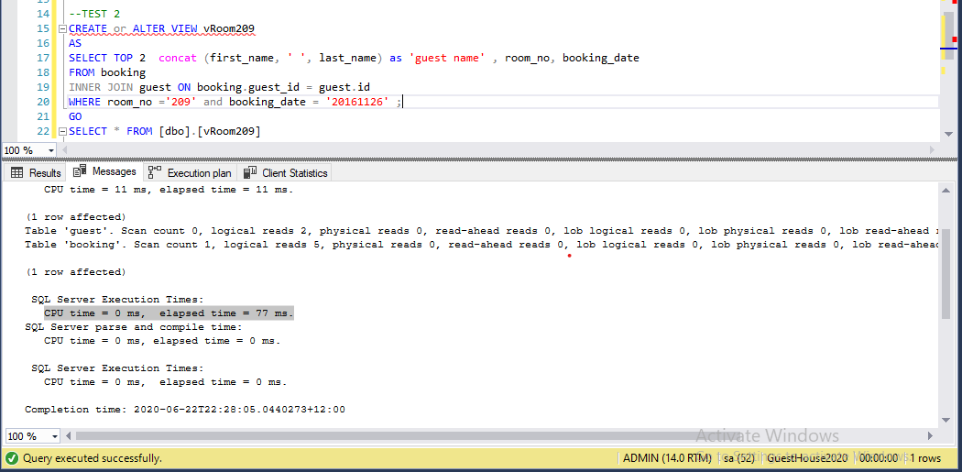

CONCLUSION:

In my first optimization(test 1 ) , elapsed time = 92 ms

According to the request : *List the people who made the booking for room number 209 on 26th Nov 2016.*I know that the number of people will not greater than 2 , so in my 2nd optimization (test 2). I use select TOP 2 to make the search more efficient. At the result, we can see that execution time (elapsed time) drop to 77 ms .